Tut1

Understanding Dependency Injection

..I can draw any thing by instantiating the respective class. But I don’t want this dependency.

So what I can do is , use polymorphism and avoid the dependency and use it at runtime. But you have to call the object at somewhere. So to remove it from the class and move it to somewhere else and let someone else let instantiate it.

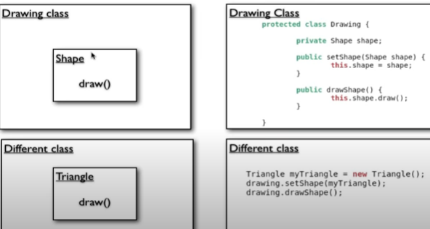

Dependency is injected using different class and spring takes care it without even writing the different class.

3) Spring Factory Bean

A spring container : it is a container of Bean rather than servlet.

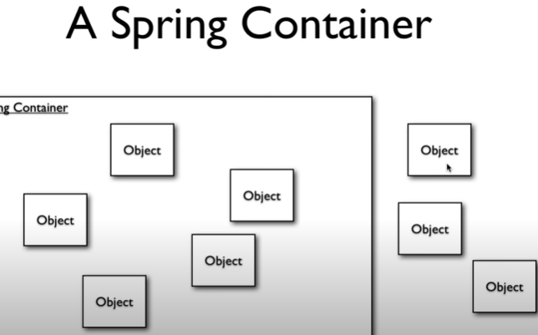

Using xml it creates all the bean factory

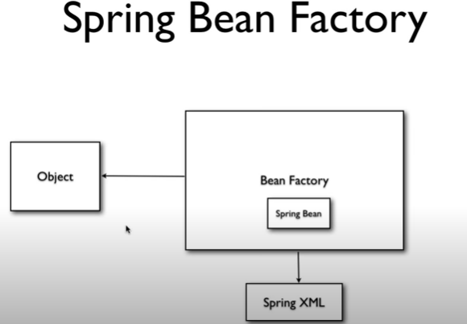

4) Code Using The Bean Factory

1. create main class

2. create a Triangle class which will contain draw()

3. create a spring.xml file for bean



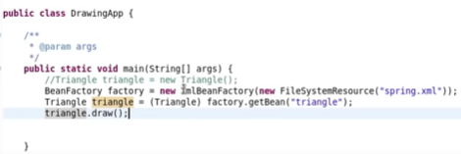

So here we did not use new.

Tuts 5) Application Context and Property Initialization

Application context is same as bean but with some additional feature

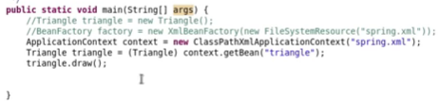

Property Initialization :

Create one more variable in a shape class and set it into xml

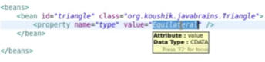

6) Using Constructor injection

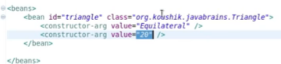

But it leads to one problem, it has to evaluate based on the type of primitive type.

3 constructor can have different datatypes for same variable

So in xml we can also give the type of variable

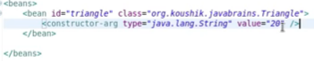

Other way to define is index.

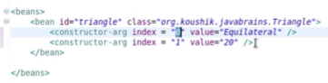

7) Injecting Objects

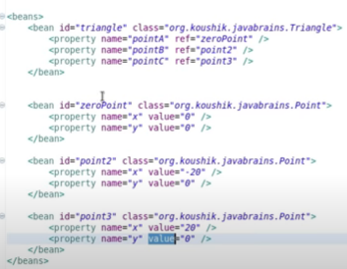

8) Inner Beans, Aliases and idref

Advantage of this is it is isolated , and same id can be used and consolidate under single bean , nothing like performance gain etc.

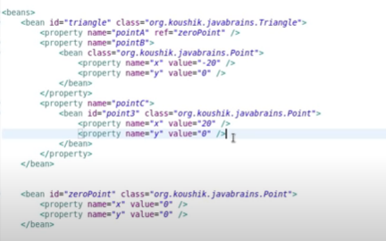

9) Initializing Collections

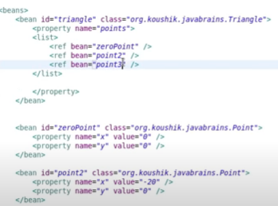

10) Bean Auto wiring

Configure the auto wiring in the xml file.

11) Understanding bean

Application context refers Spring XML for spring bean

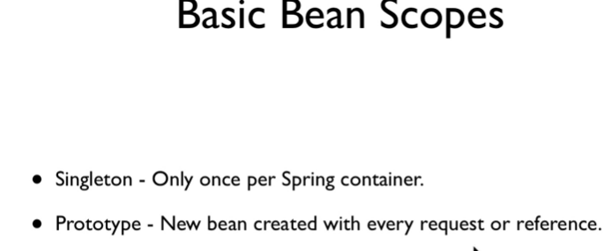

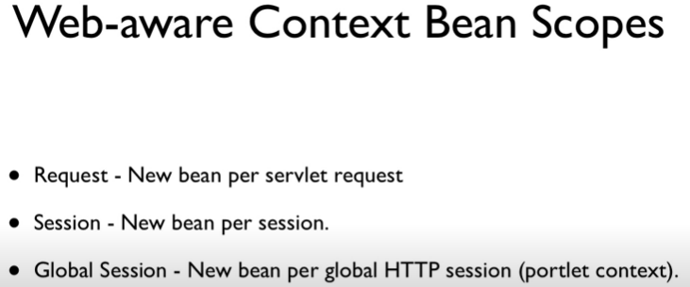



We can define the scope what ever we want

13- Bean definition Inheritance

14- LifeCycle Callbacks

However initialization is done dirctly in spring boot

Registering hooks

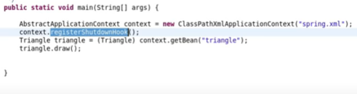

Initializing bean

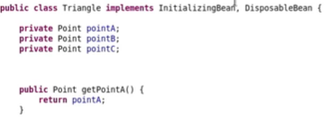

The method will be call when initialized or destroyed

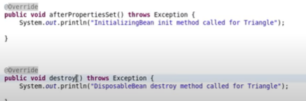

Method 2

For init and cleanup





We can also declare at global level under beans -> the default and cleanup method

15- Writing a BeanPostprocessor

1. To display name of bean , create a class which implements BeanPostProcessor.

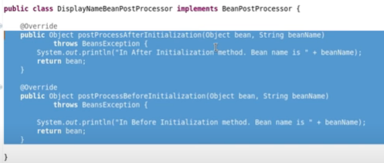

output

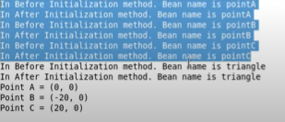

These method will execute each time if any objects get’s initialized